**Step 1: Github Account Creation**

1. Go to Github and click on “Sign Up” to create a new account.
2. Follow the instructions to complete the account creation process.

**Step 2: Git Installation**

1)For download and install Git, Search **git install** on browser, and click on windows link then git will be installed for windows.

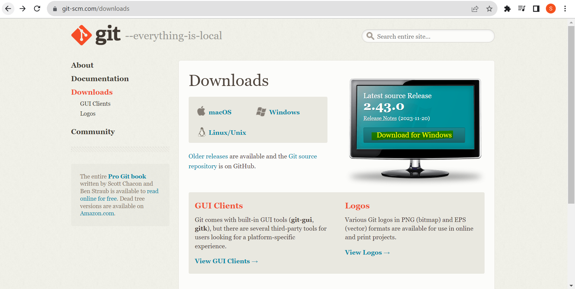

2)Open a terminal and verify the installation by typing:

git --version

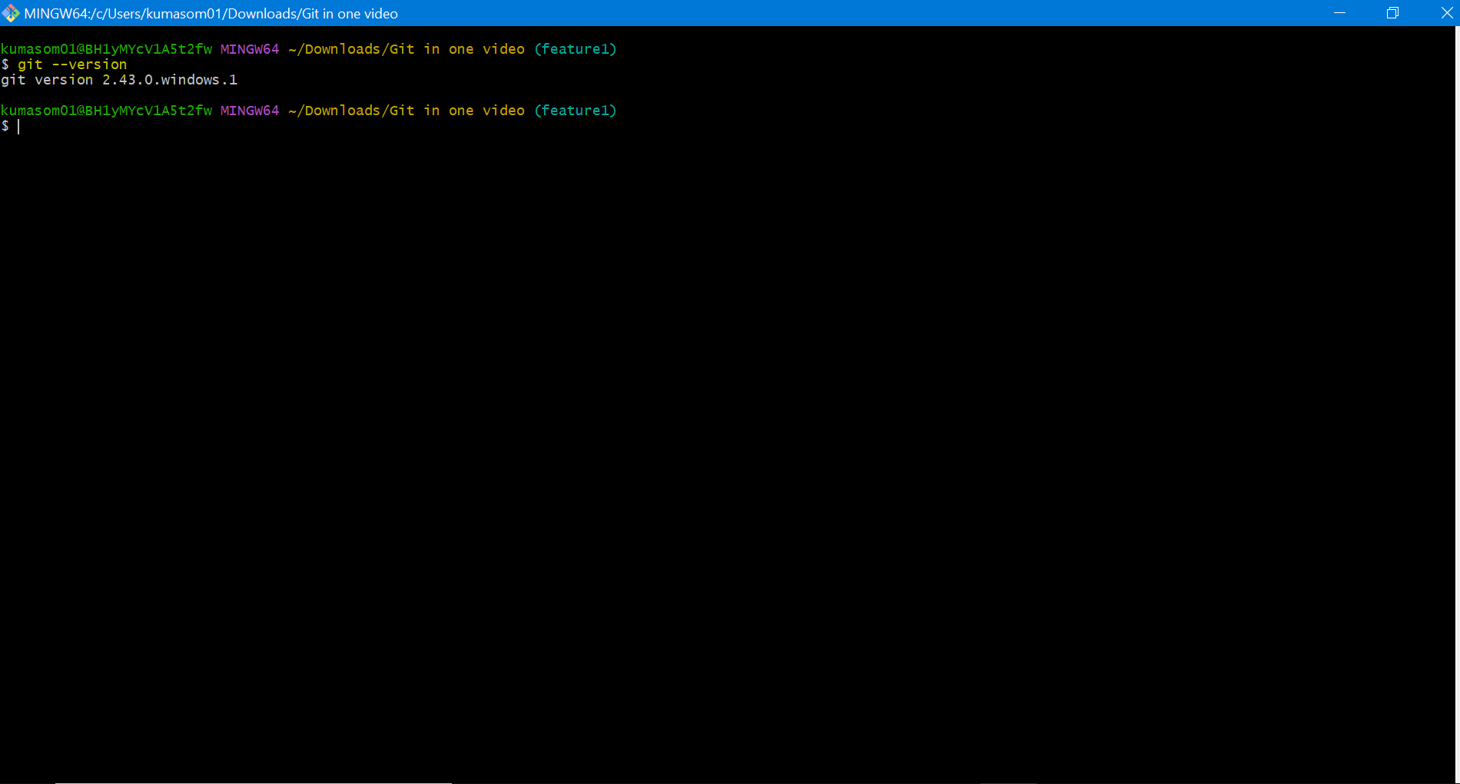

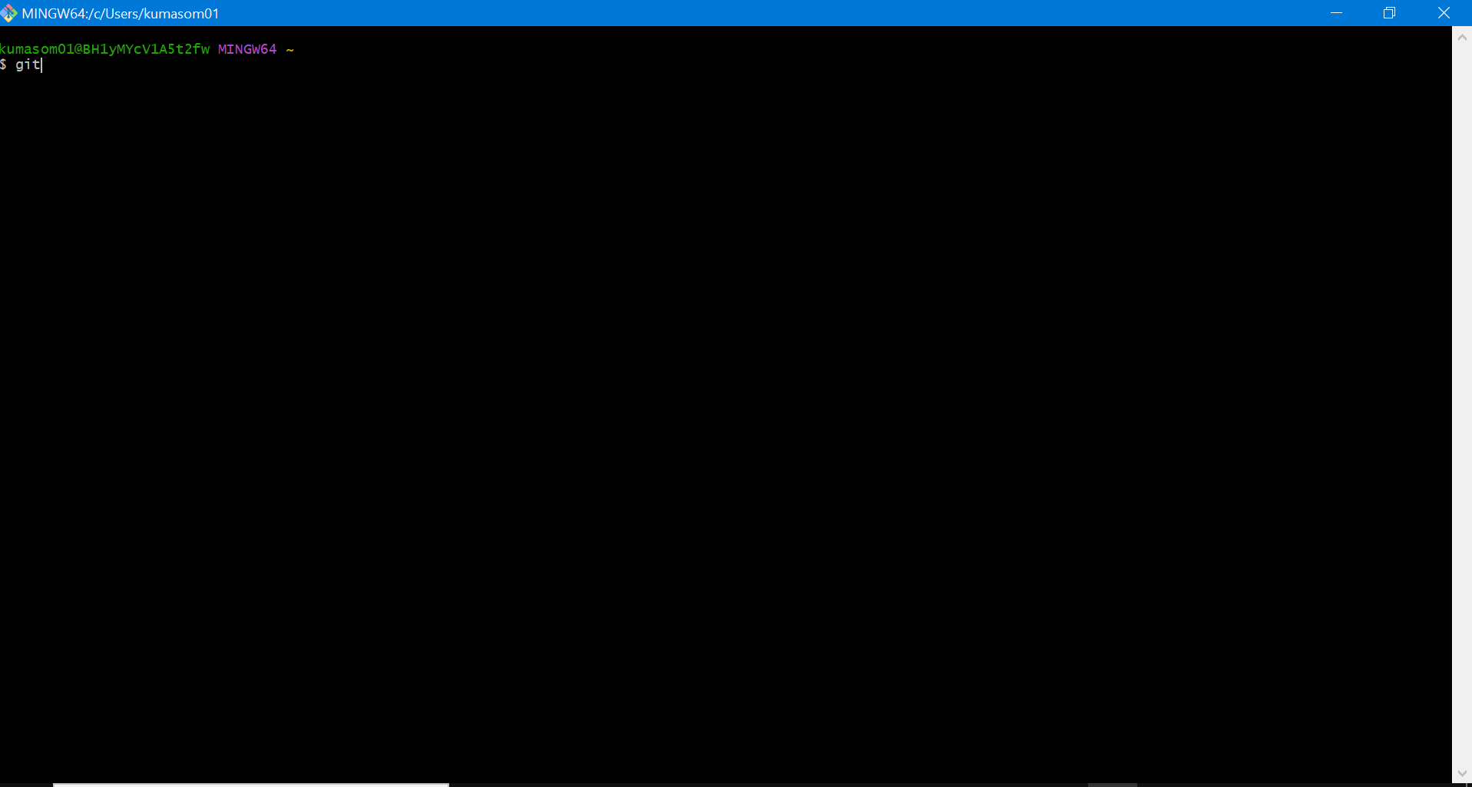

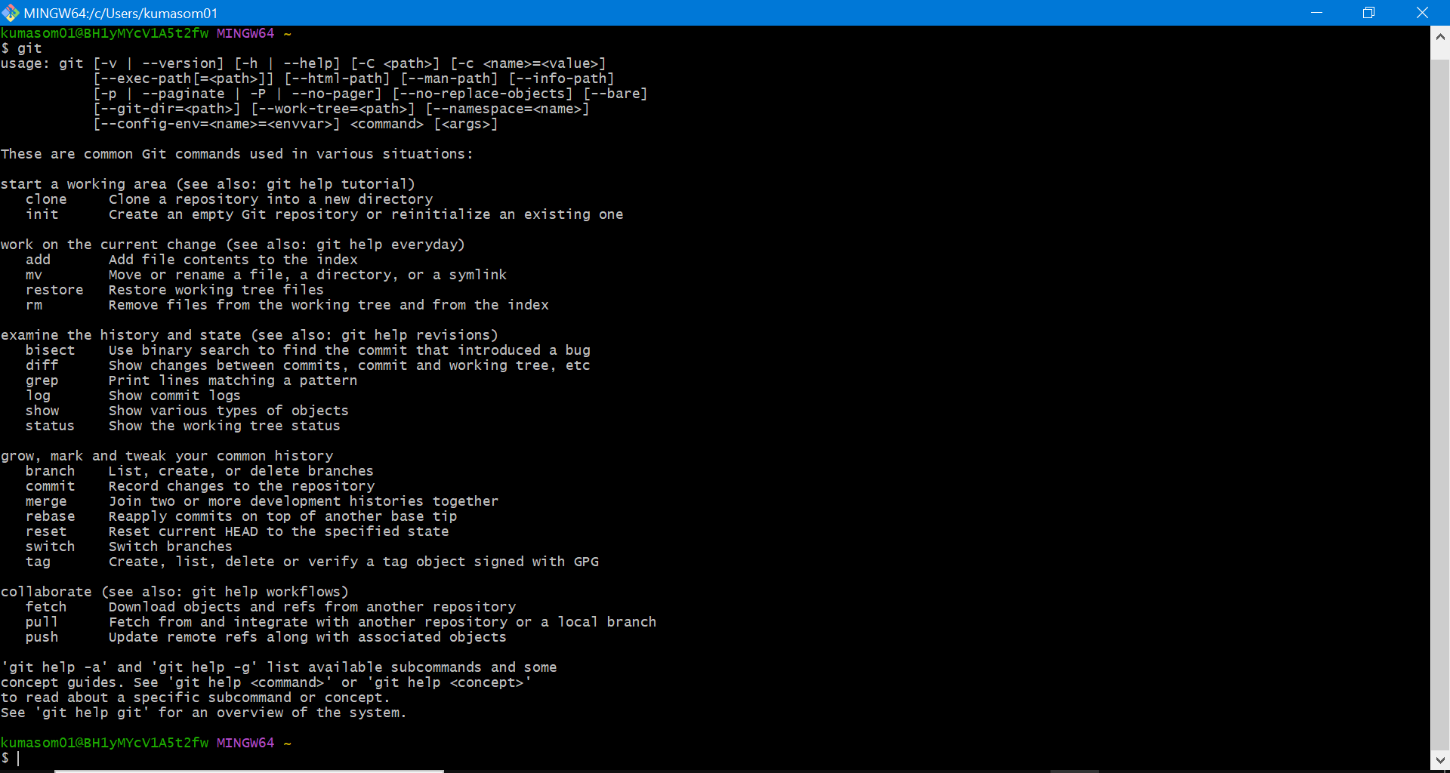

3) Execute the below command

1. git config --global user.name “Somya”
2. git config --global user.email “somya.kumari@bakerhughes.com”
3. git config --list
4. git config user.name
5. git config user.email

Anyone want to know who did this changes. They are easily Able to know using name and email

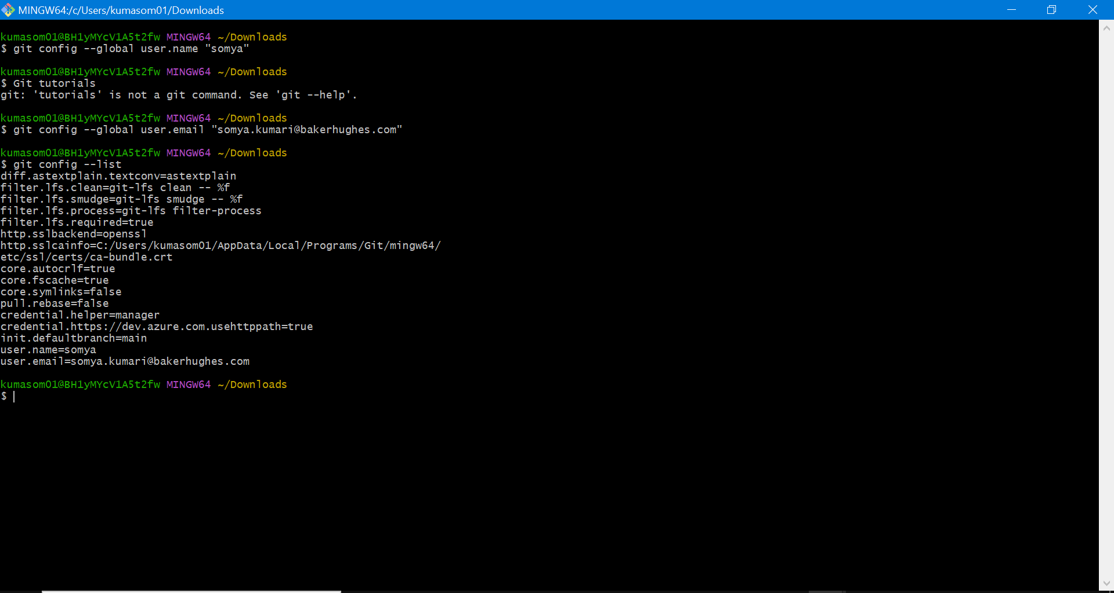

**Step 3: Repository Creation**

1)Login to your Github account

2) Click “new “to create new repository.

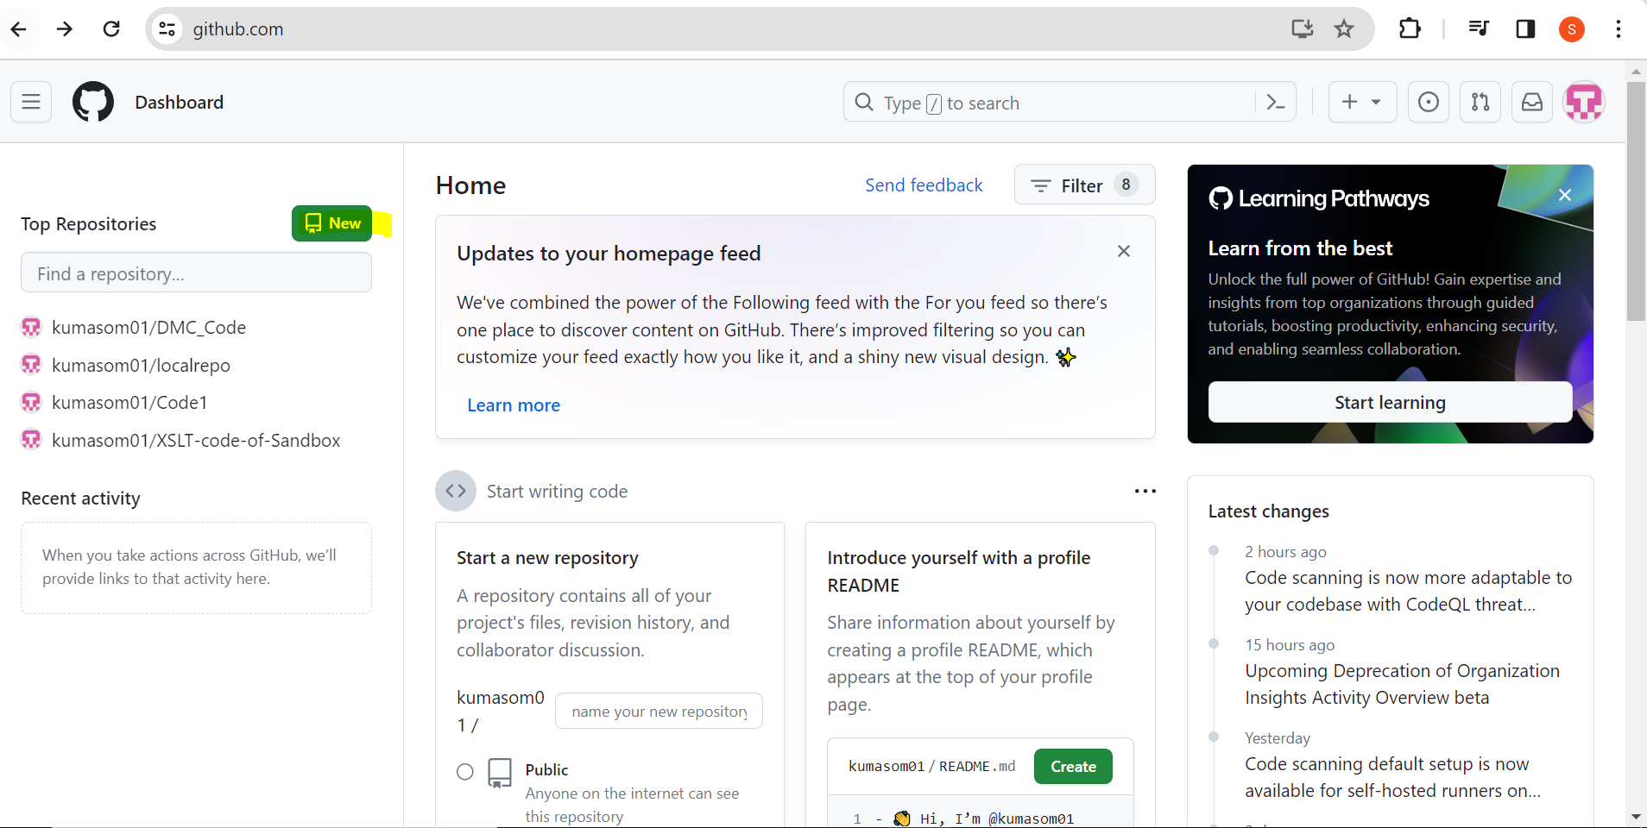

3)Fill the repository name, description and other options.

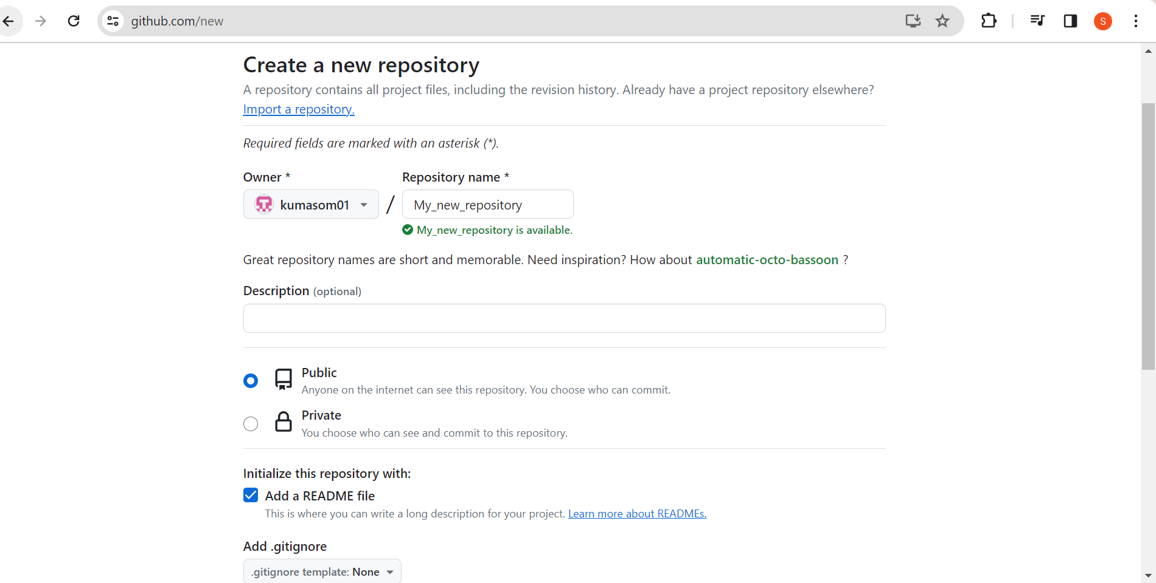

1. Click “create Repository”

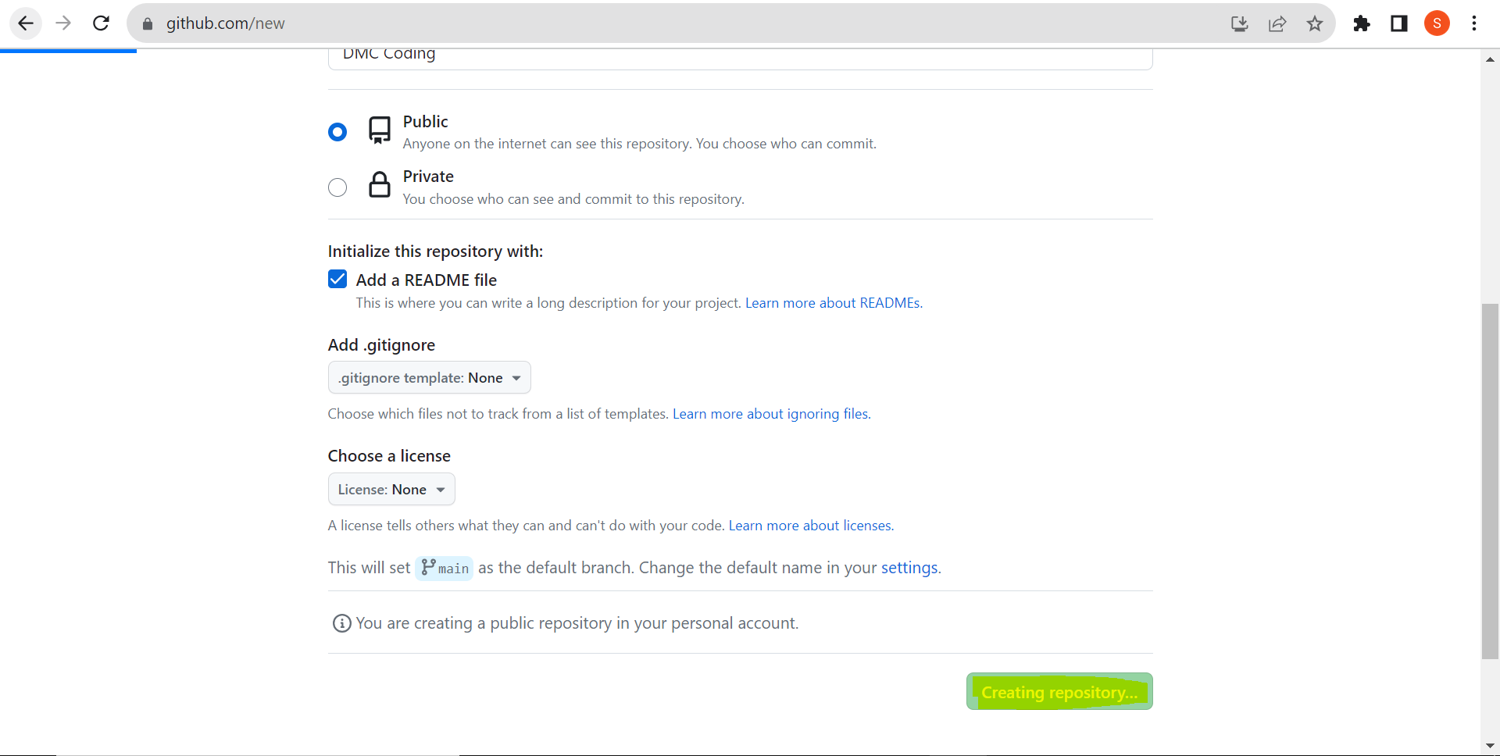

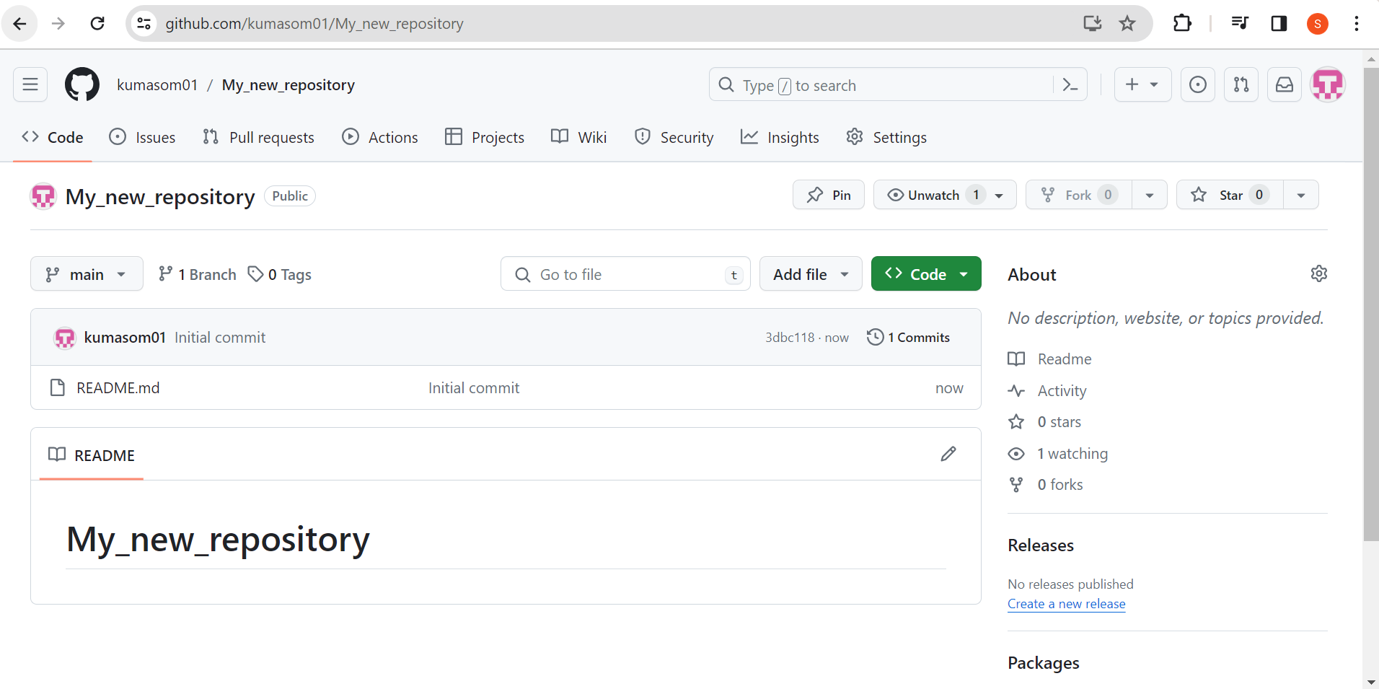

Click on Add file and upload Files.

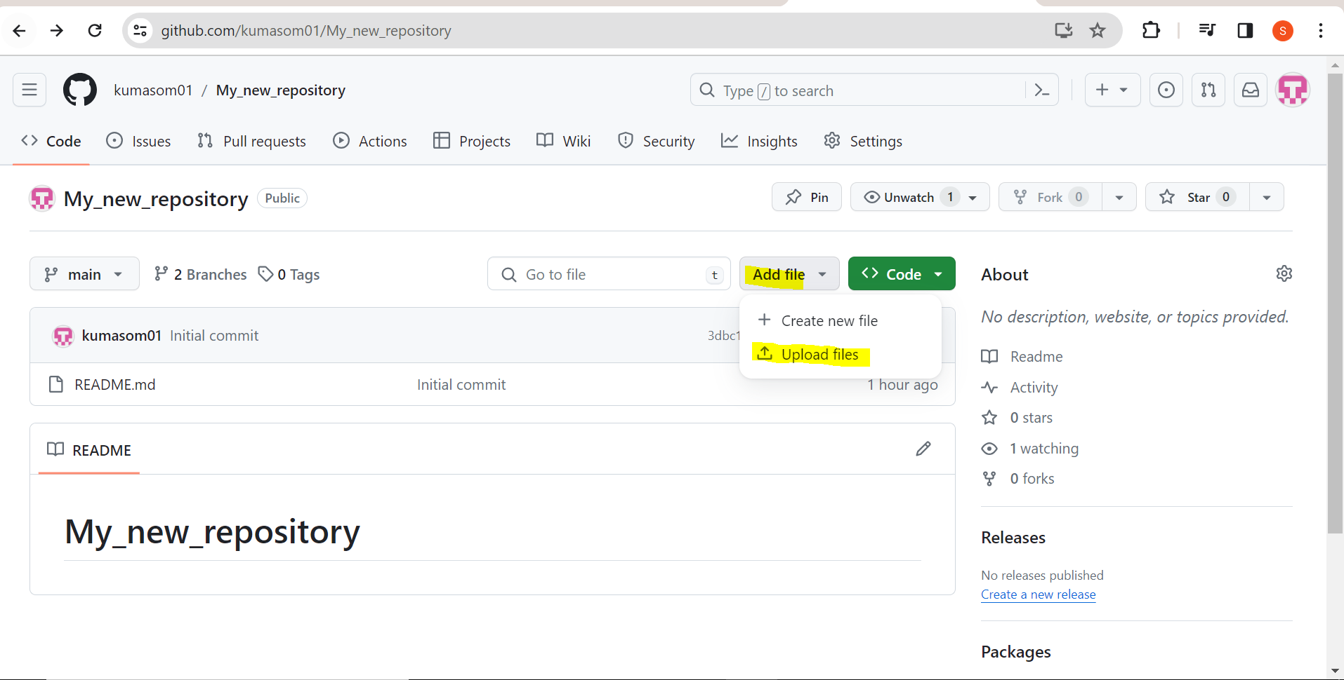

Click on Choose your file

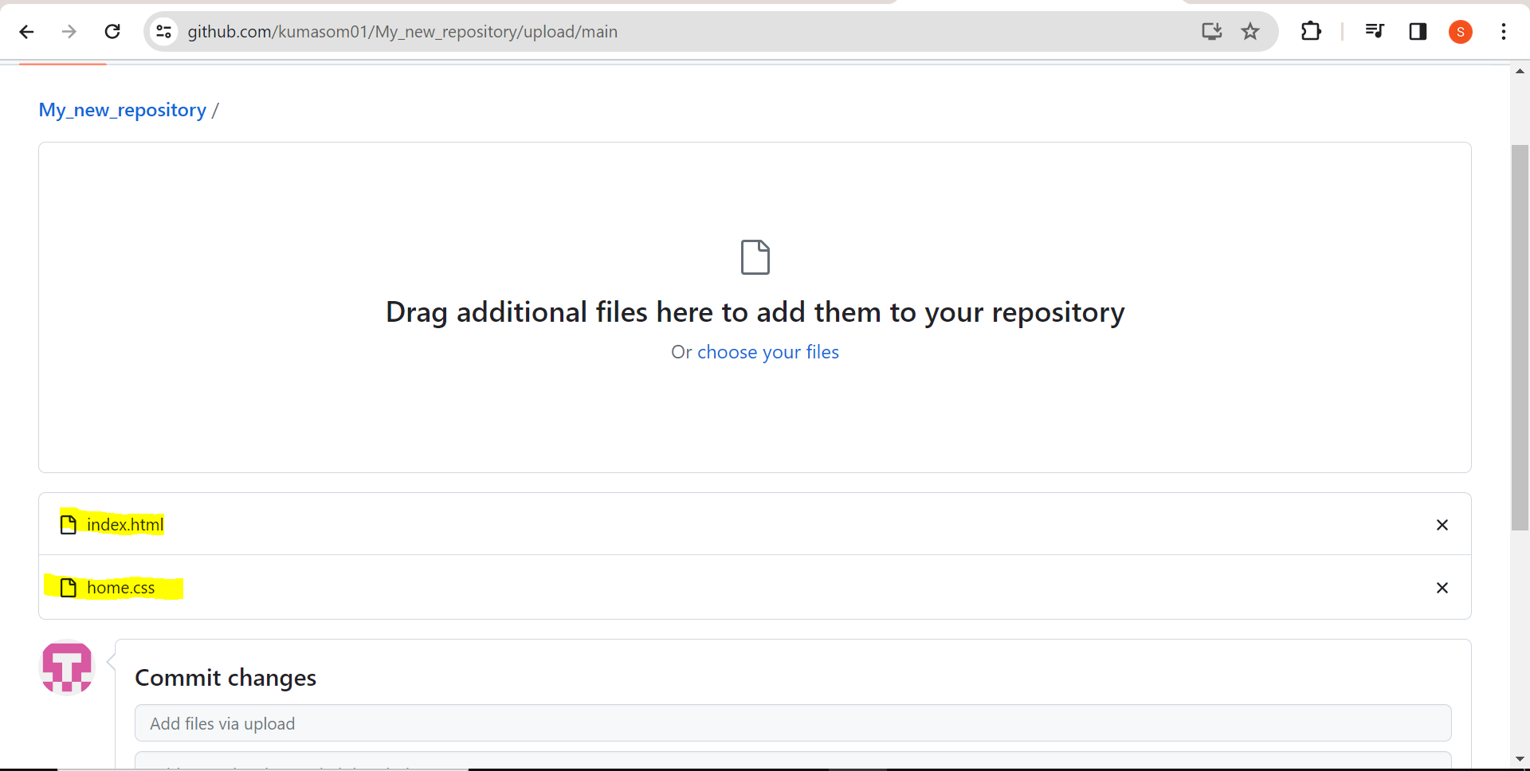

Files has uploaded then click on commit changes.

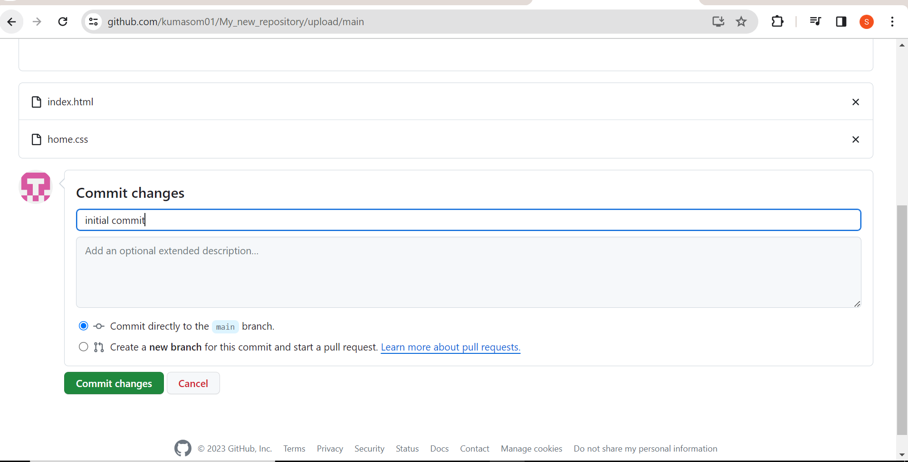

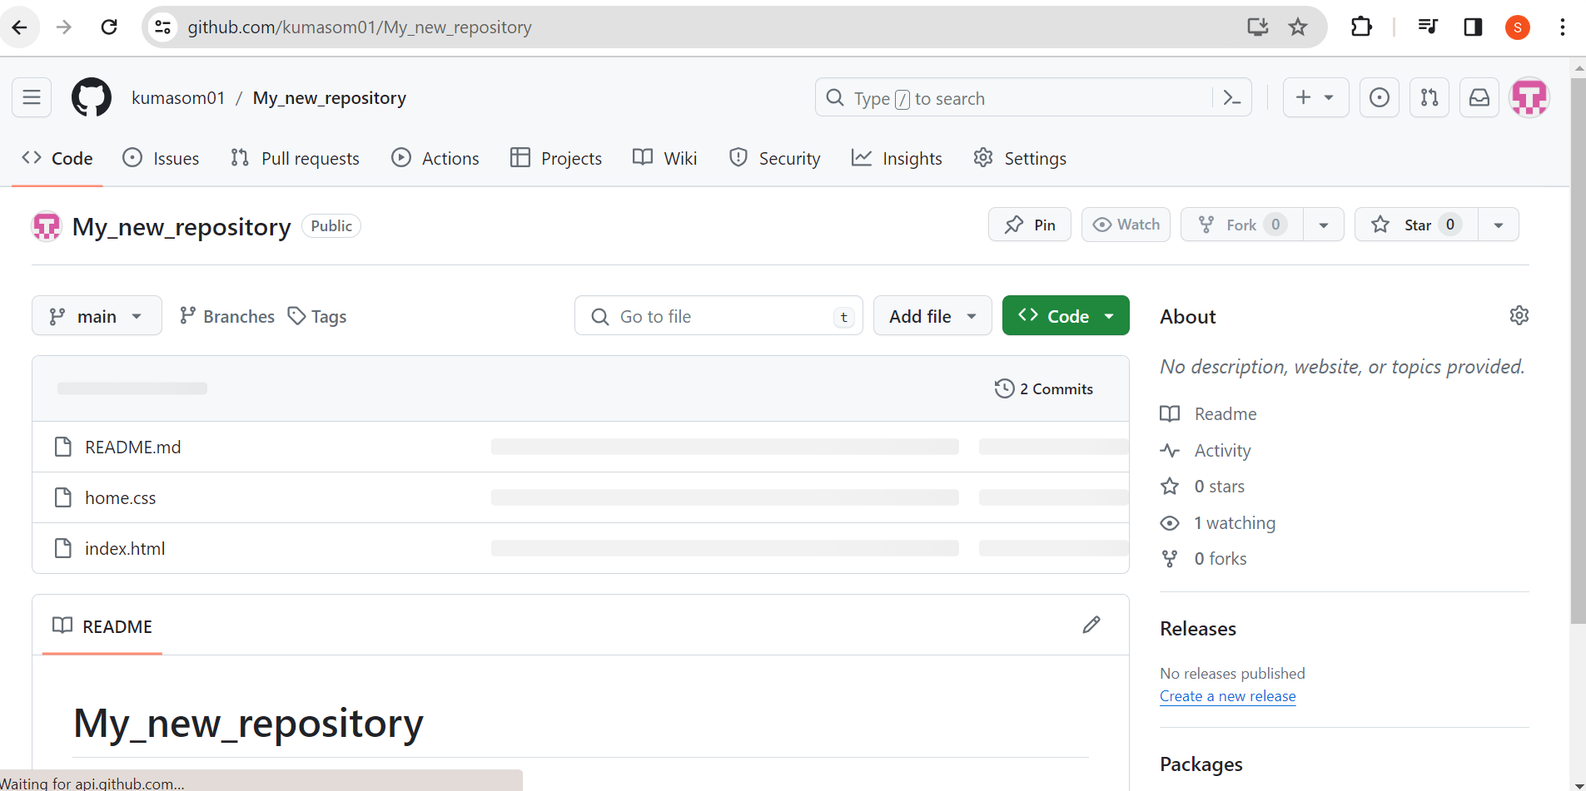

**Step 4: Clone the Repository**

1)On the GitHub repository page, click the green “Code” button and copy the repository URL.

2)Open a terminal and navigate to the directory where you want to clone the repository.

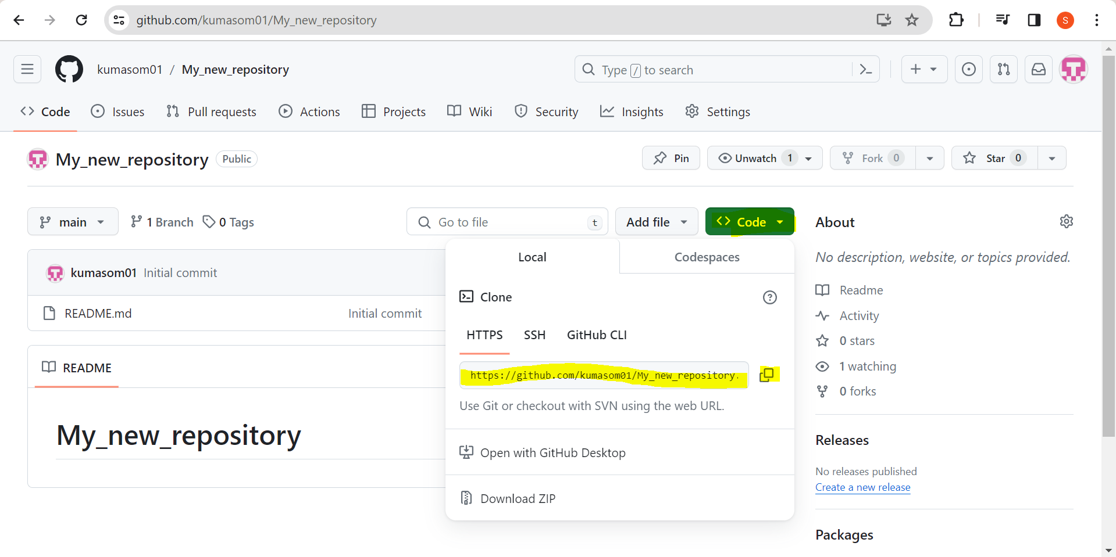

3)Run the following command, replacing <repository-url> with the URL you copied.

**git clone<repository-url>**

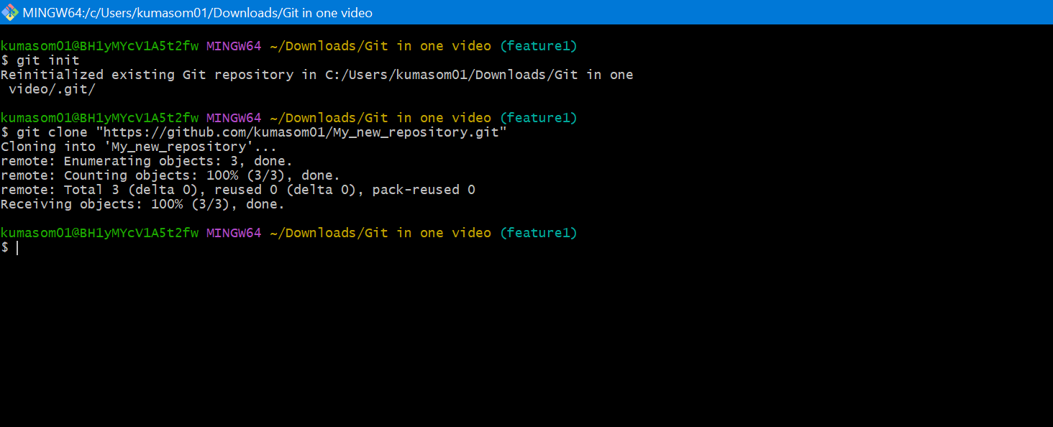

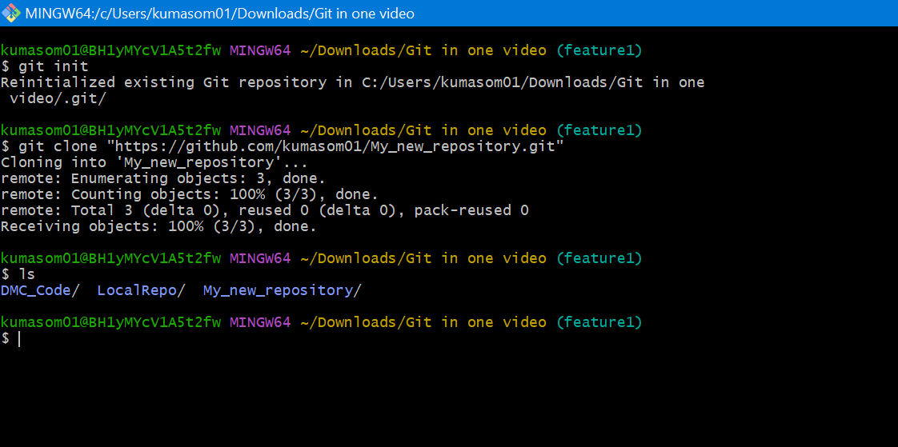

**Step 5: Branch Creation**

1)Change into the repository directory:

cd <repository-name>

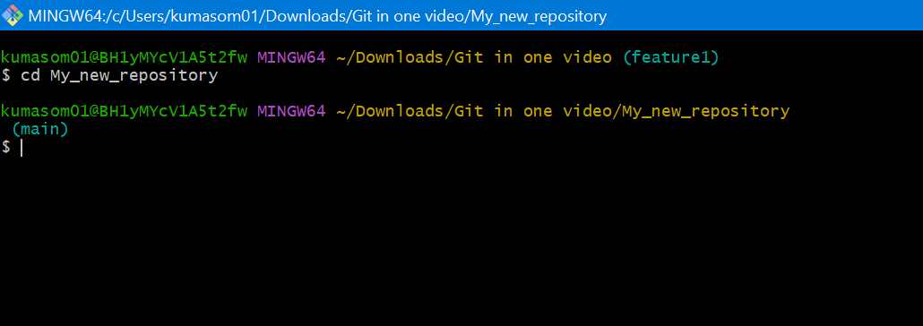

2)Create a new branch

Click on main, View all branches

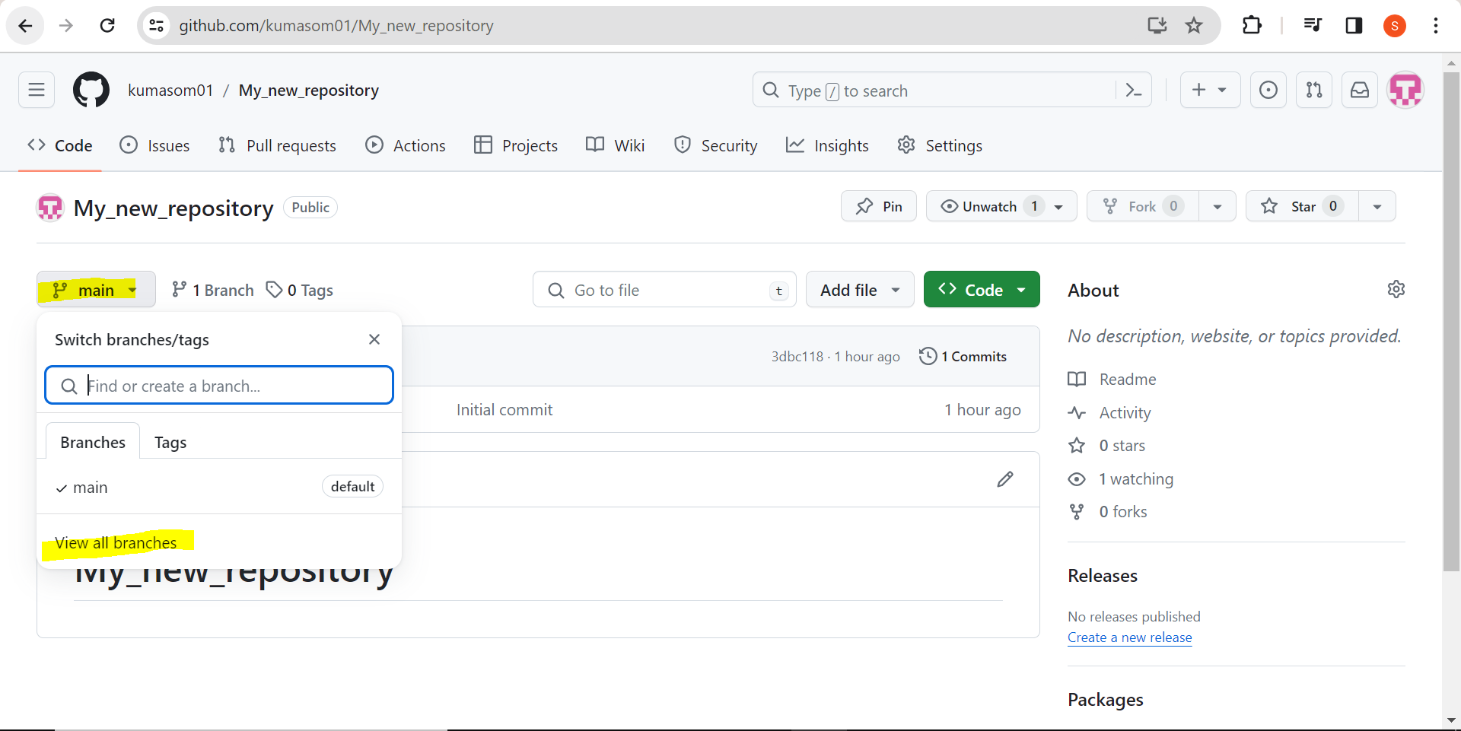

Click on New branch

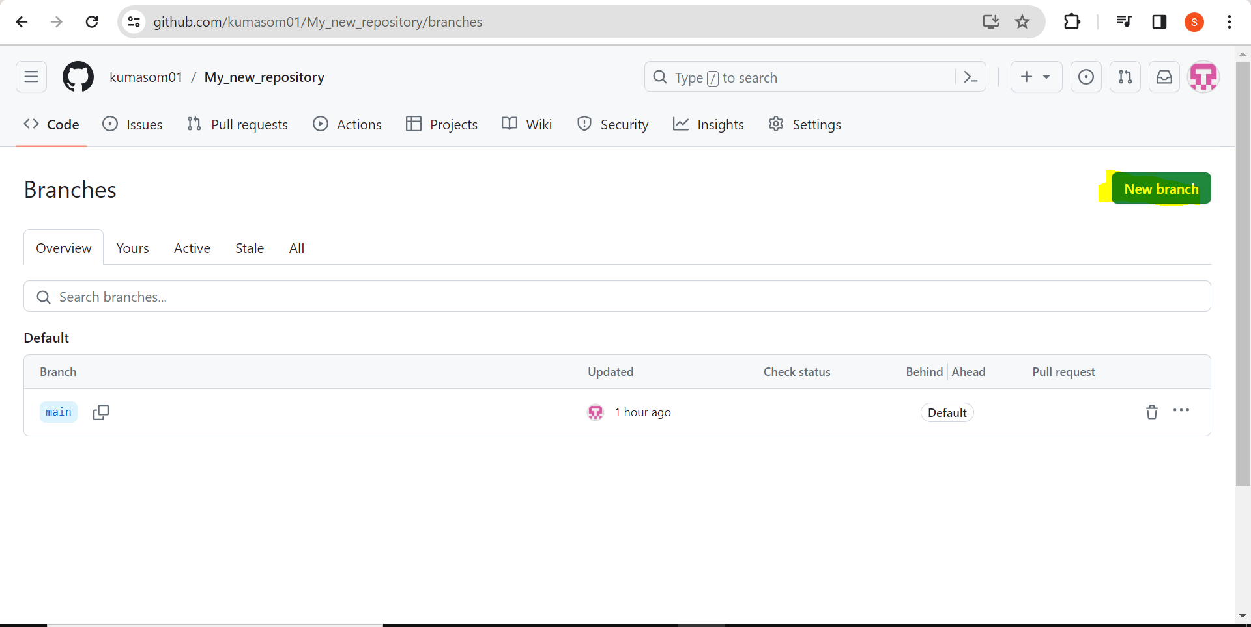

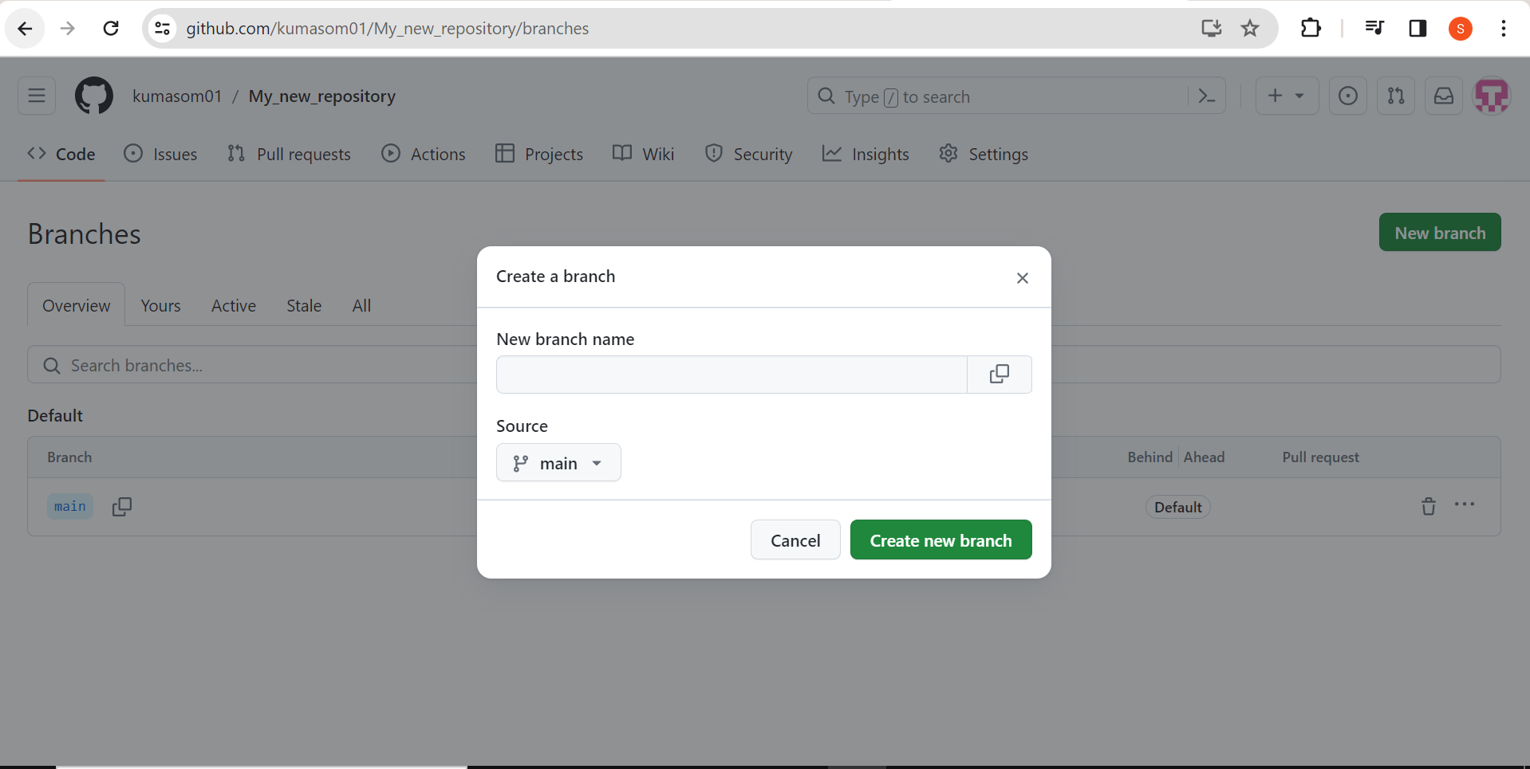

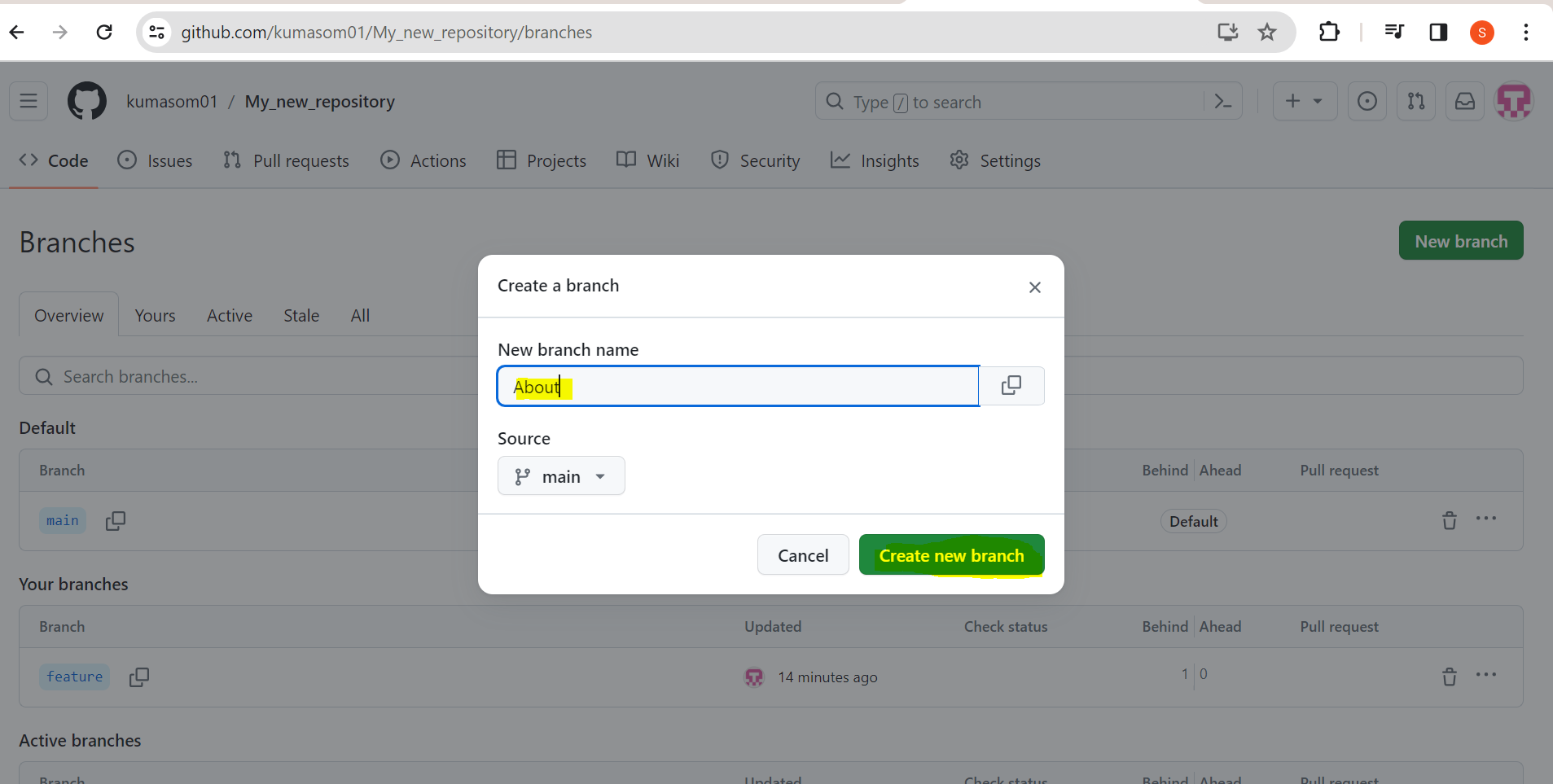

Click on Create new branch

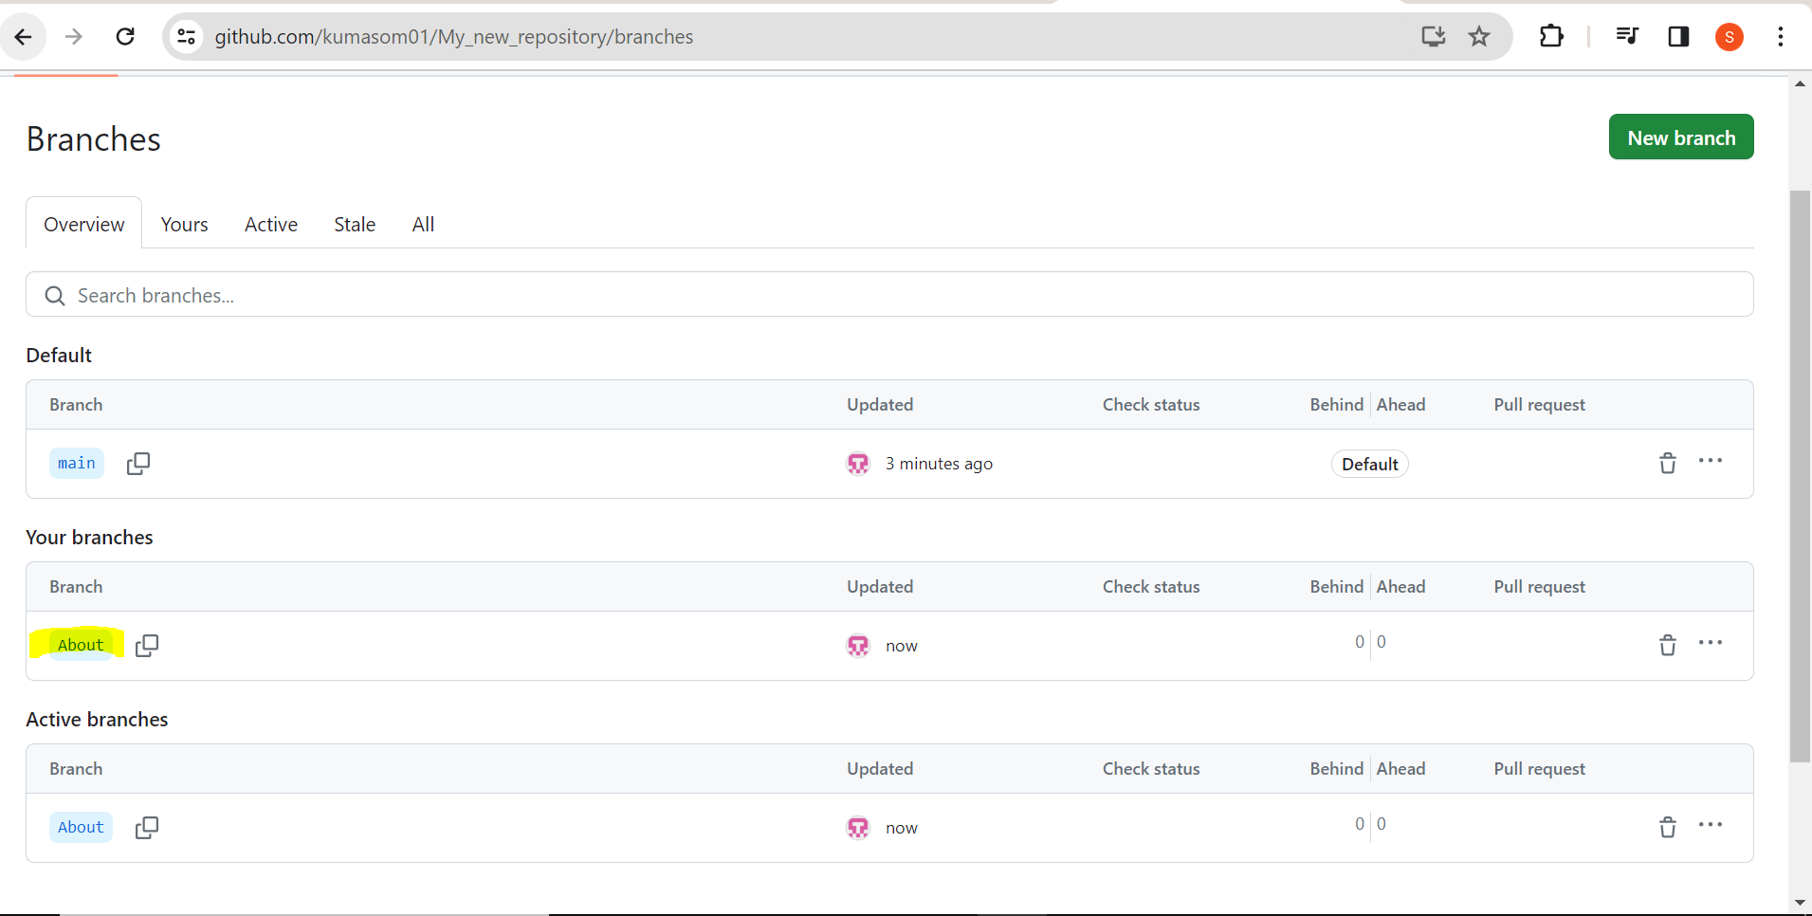

Now, It is showing 2 branches

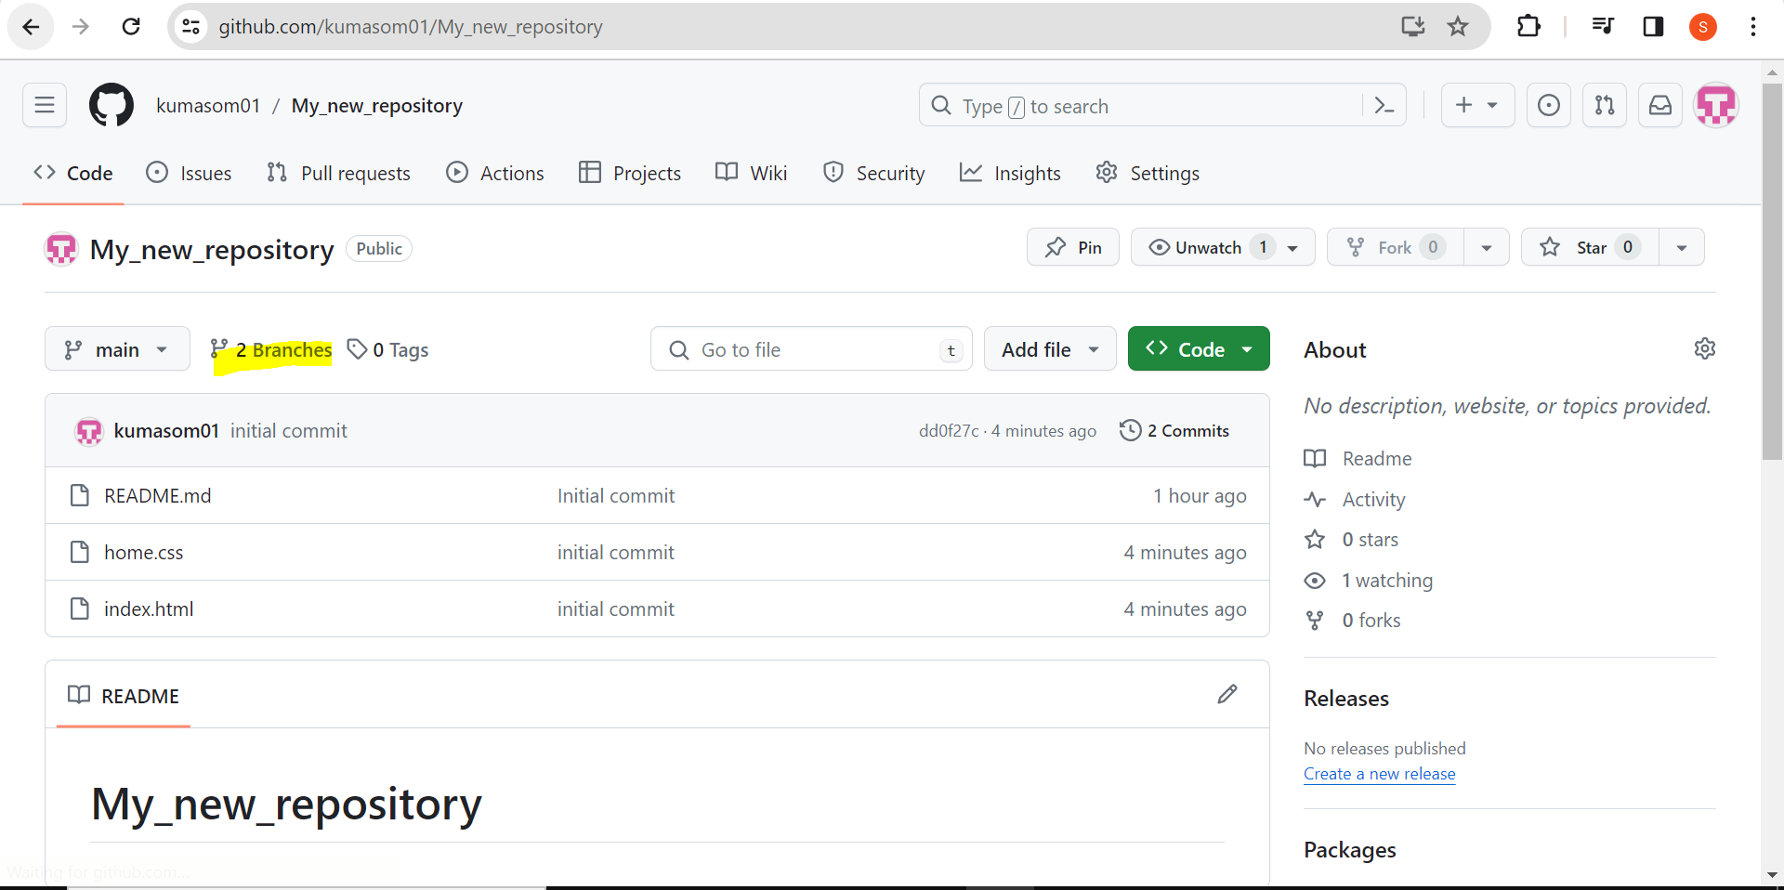

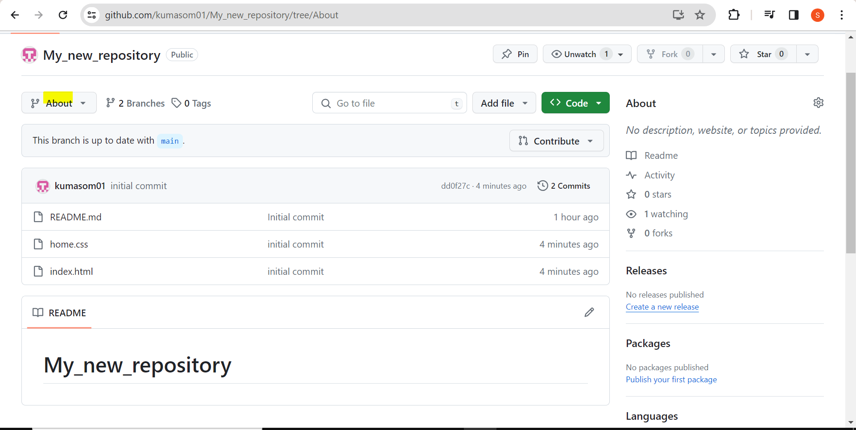

I want to add new file about.html on the new branch which I kept name About.

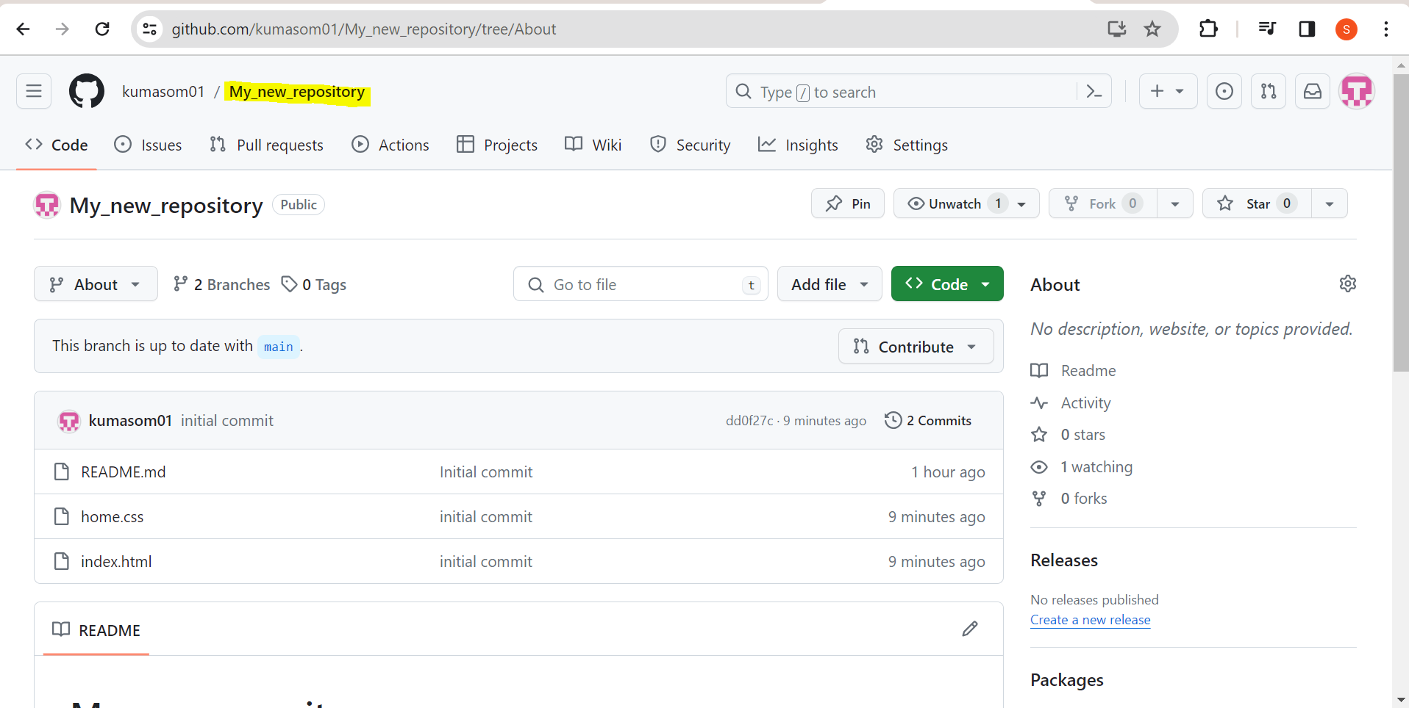

Click on Add file and upload files “About.html” in new branch.

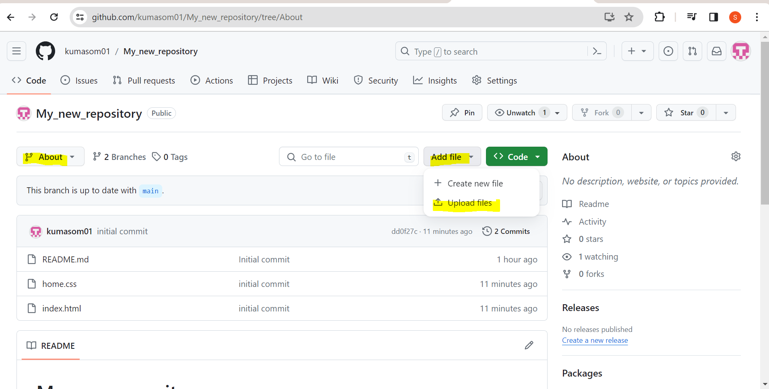

I have task to create a page on about branch.

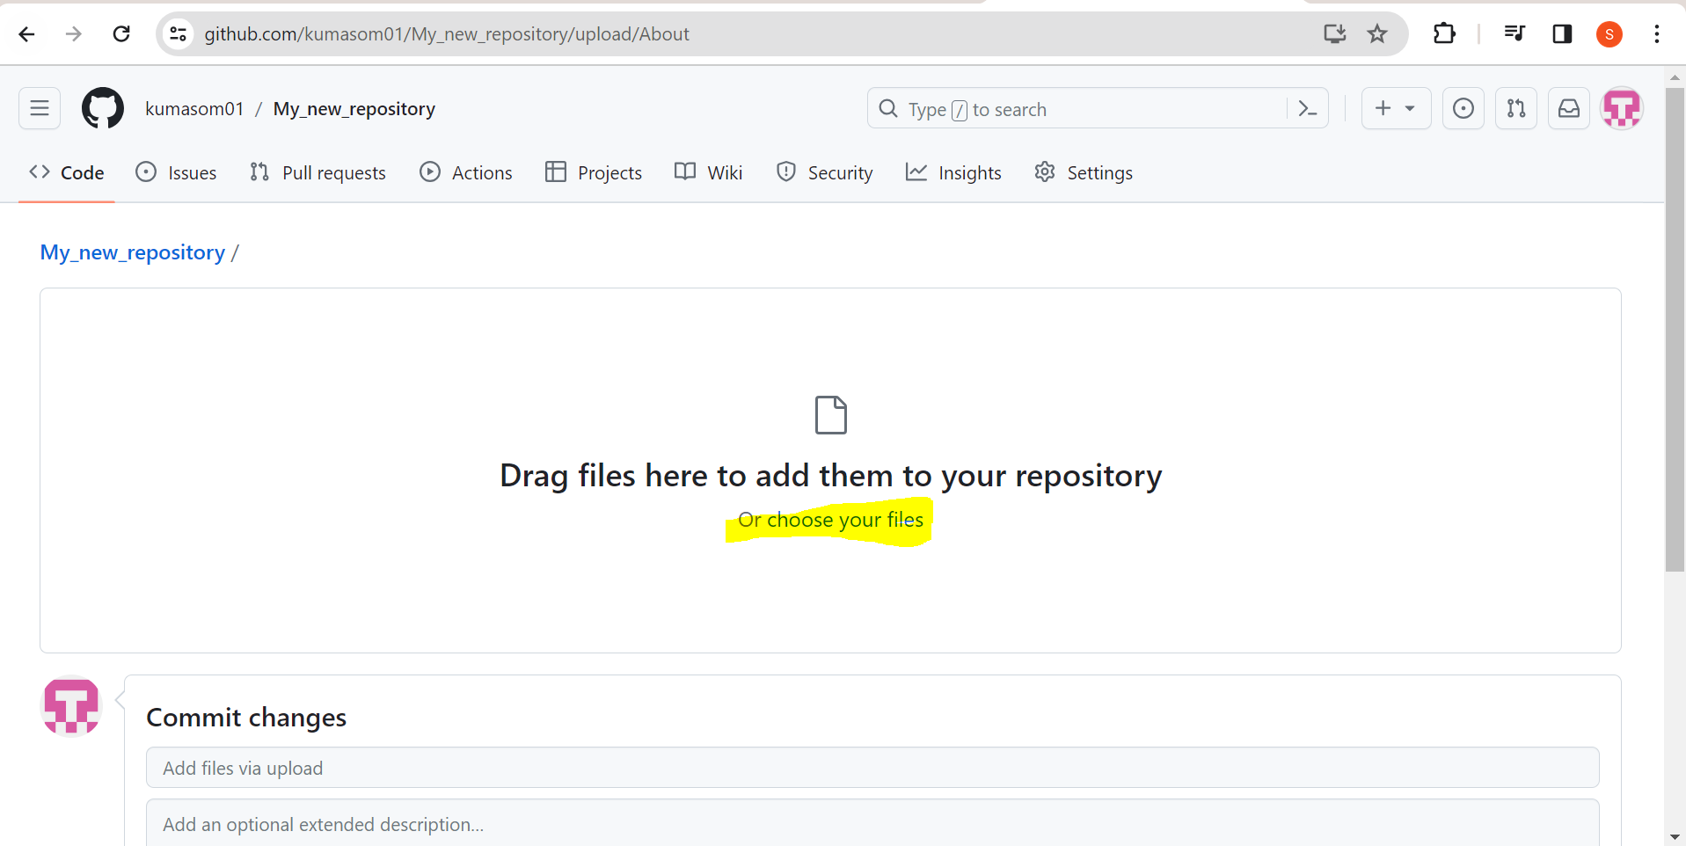

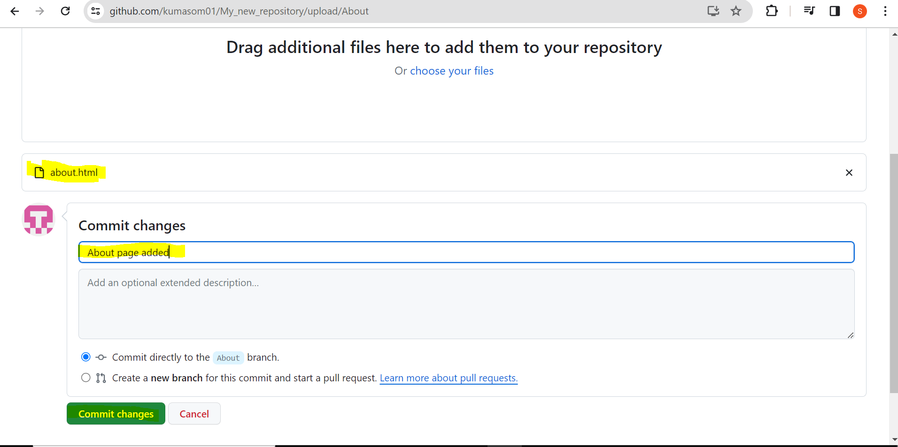

We can see the code of about.html in our new branch “About” which is successfully uploaded.

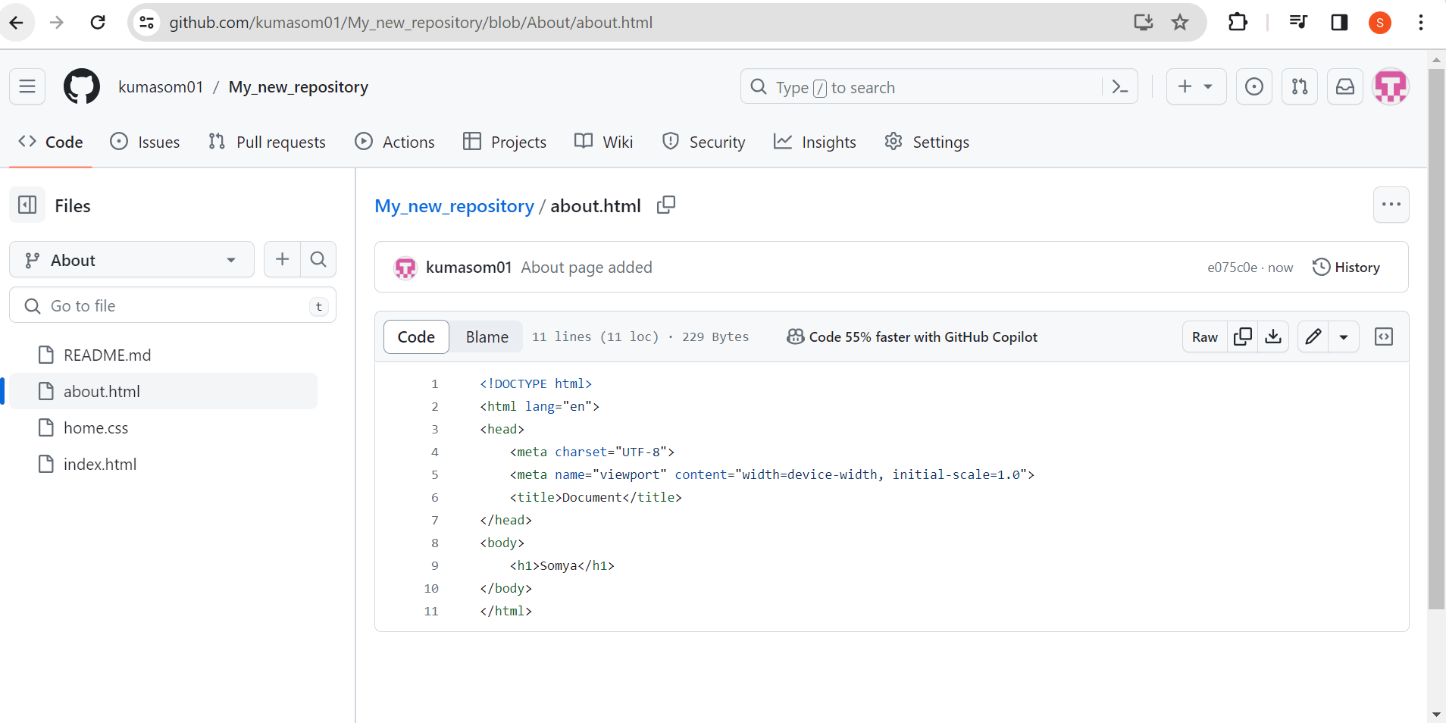

**Step 6: Create a Pull Request on Github**

1)Go to your repository on Github

2)Click on the “Pull Requests” tab

3)Click “New Pull Request”

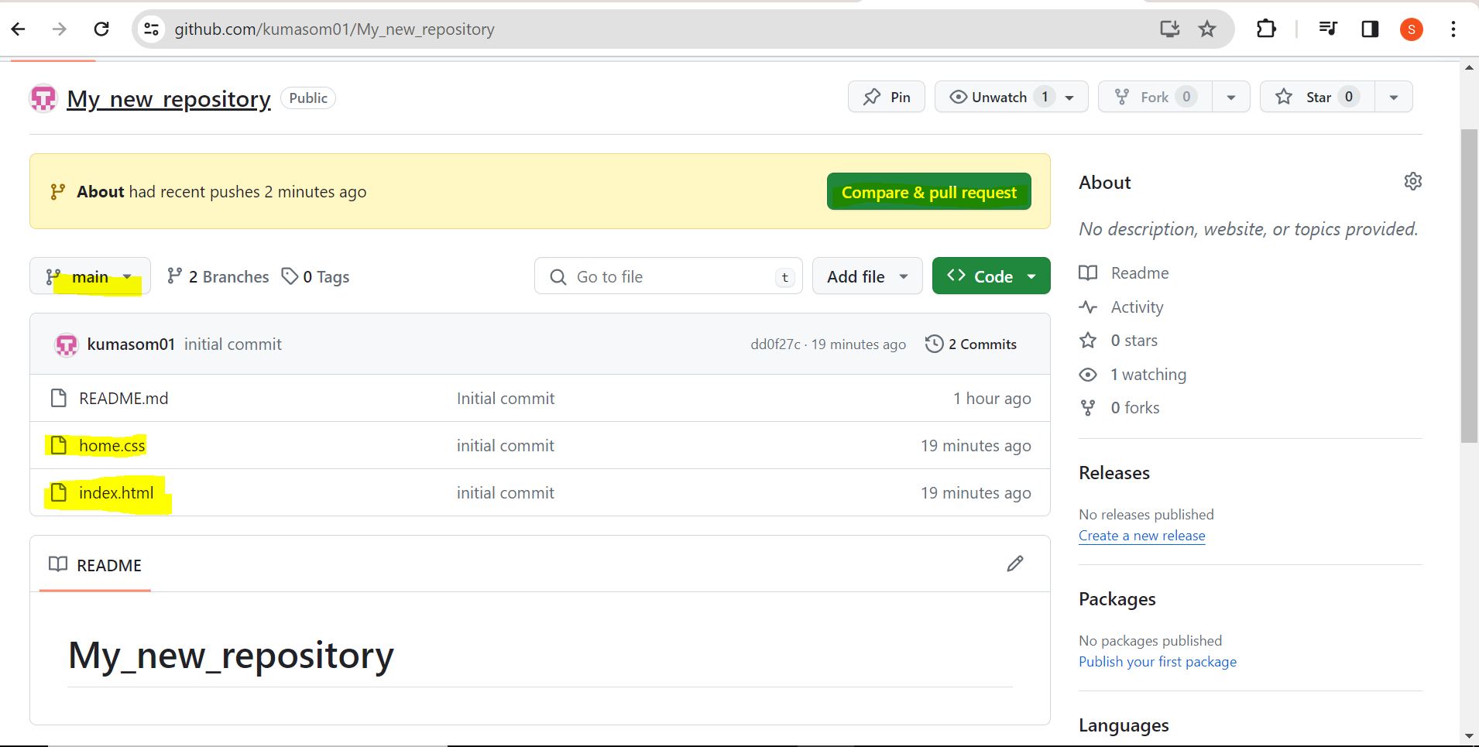

In our main file, about.html is not available so, we add this file.

Click on compare & Pull request

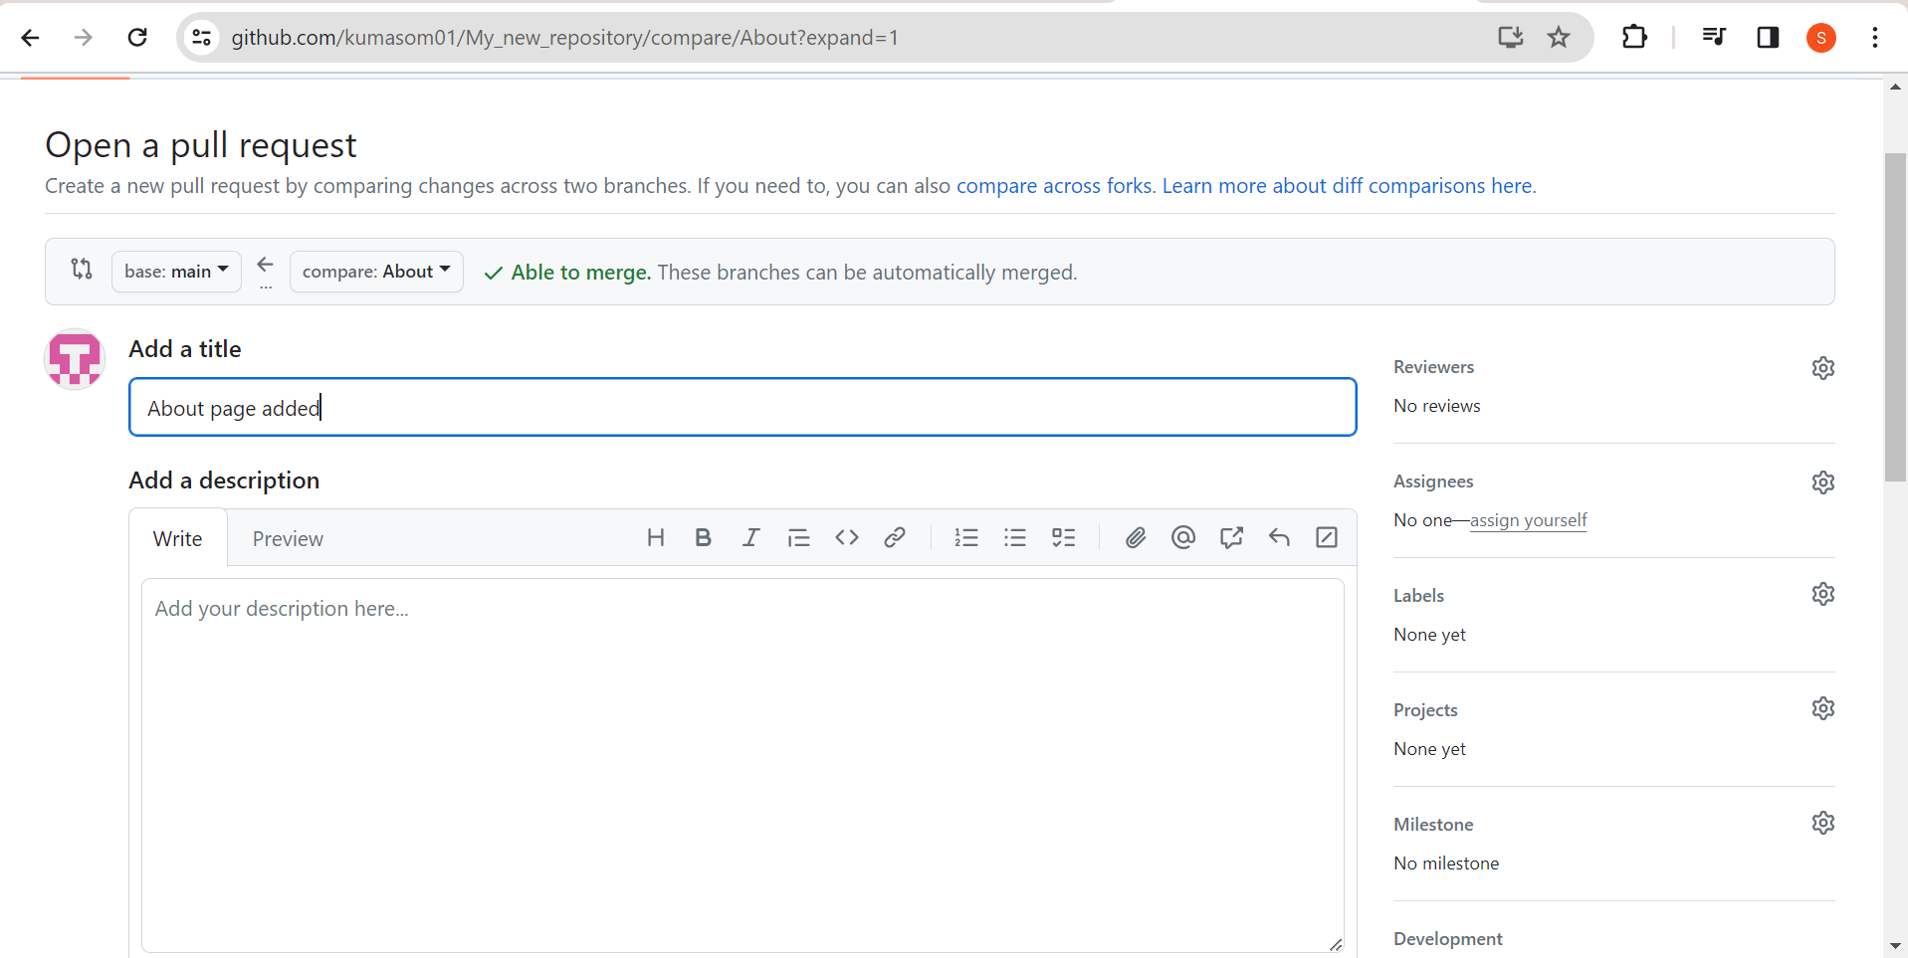

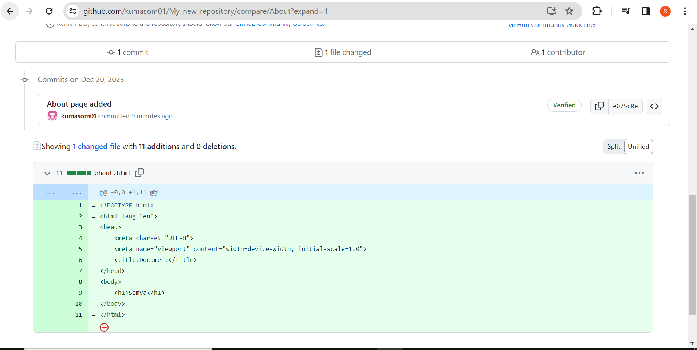

Click on Create Pull Request

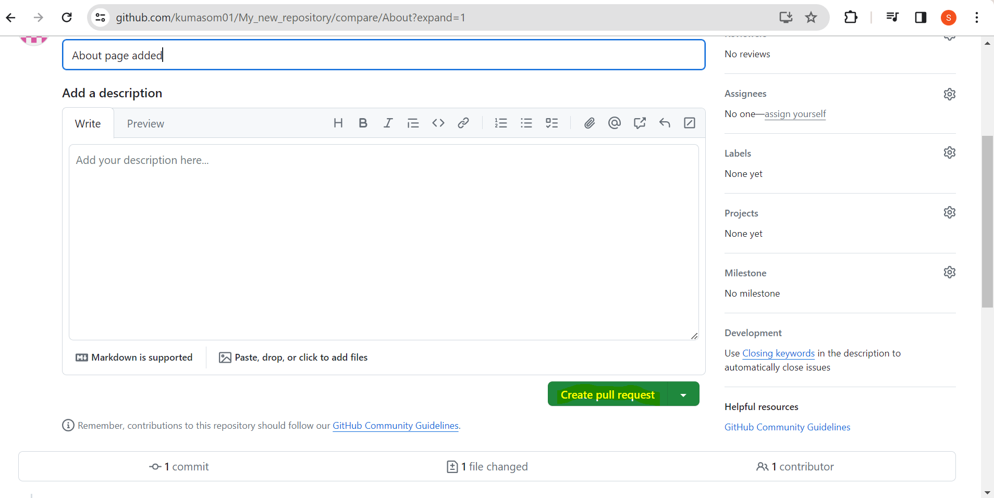

**Step 7: Merge the PULL Request**

1)On the Pull Request page, click “Merge Pull Request”

2)Confirm the merge.

Click on Merge Pull Request

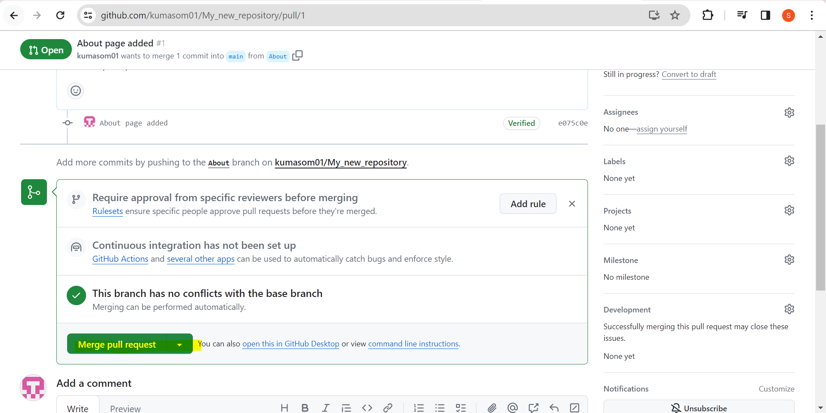

Click on confirm merge

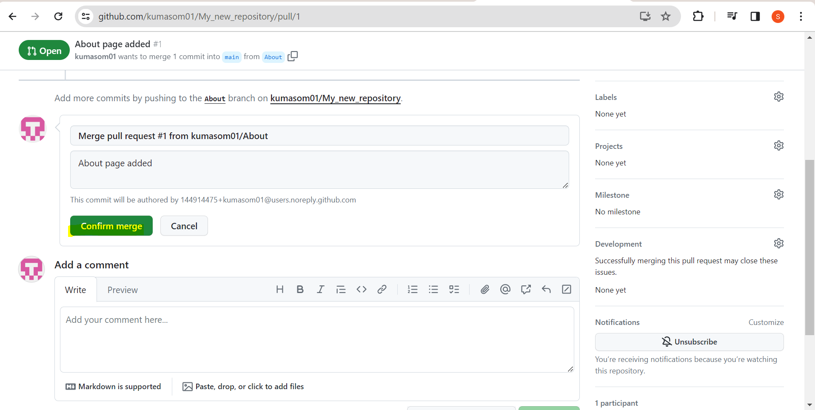

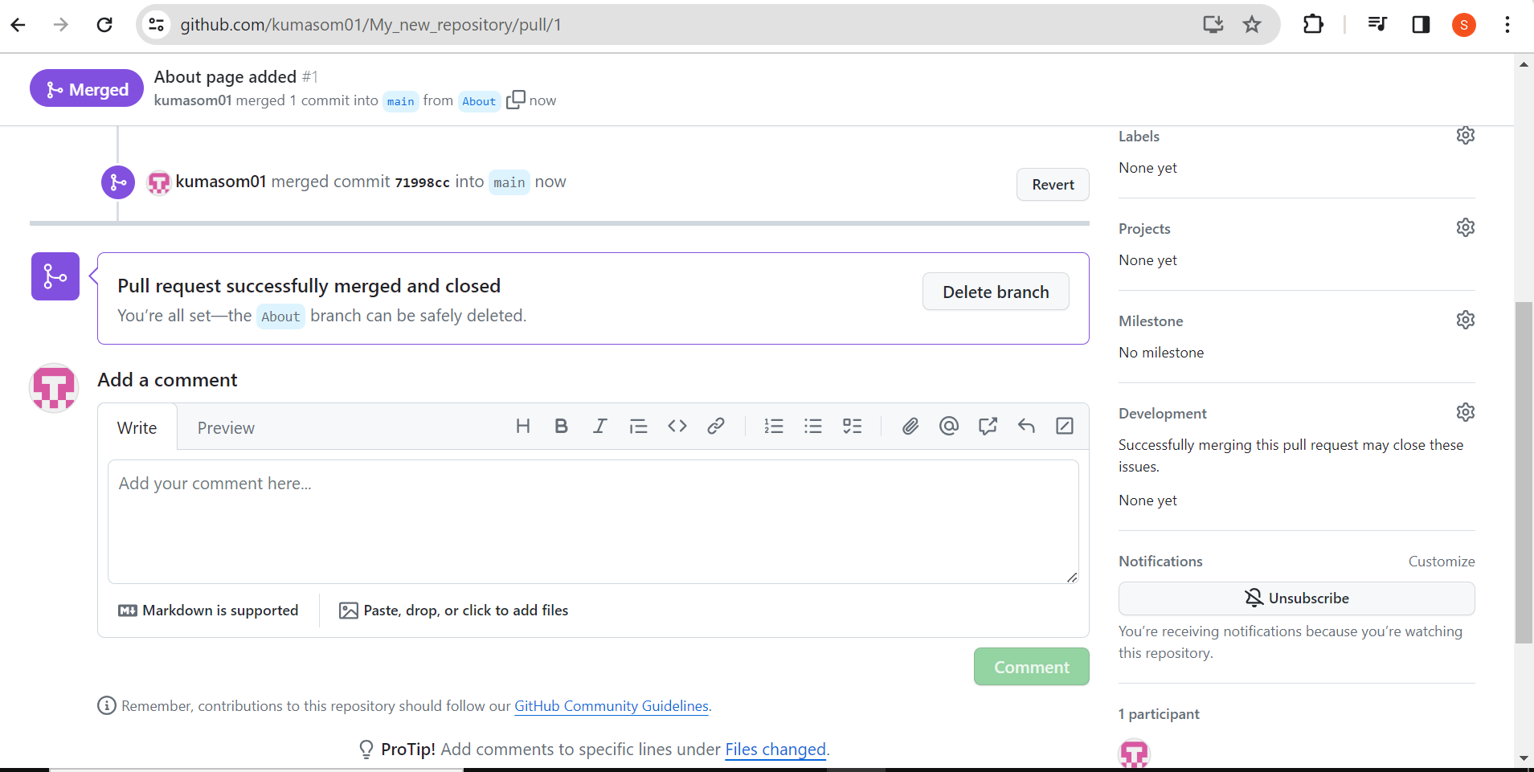

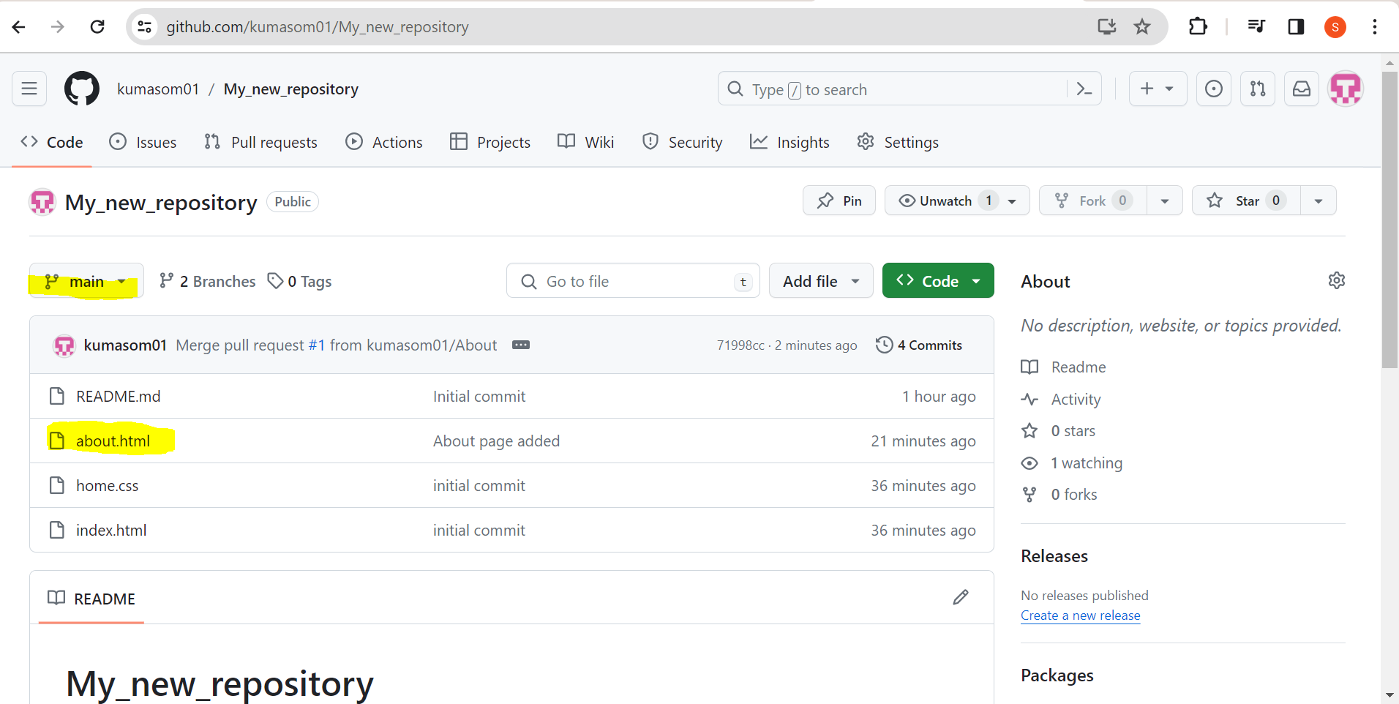

In my main branch, New file about.html has added after merged.